|  |
| --- |
| [DRAK KNIGHT studio] |
| Unity Mobile Game Design |
| **图片包含 图示  描述已自动生成Side Scroller Platforming Game** |
| Version #01  All work Copyright © 2020 by Agent Shooting Games.  All rights reserved. |
| **[Han Zhan]** |
|  |

|  |
| --- |
| October 3rd 2020 |

**Table of Contents**

[Your Table of Contents should go here. Make sure that your document’s sections are hyperlinked to their corresponding pages.]

1. **Game Overview**
2. **Game Play Mechanics**
3. **Camera**
4. **Controls**
5. **Saving and Loading**
6. **Interface Sketch**
7. **Menu and Screen Descriptions**
8. **Game World**
9. **Levels**
10. **Game Progression**
11. **Characters**
12. **Non-player Characters**
13. **Enemies**
14. **Weapons**
15. **Items**
16. **Abilities**
17. **Vehicles**
18. **Script**
19. **Scoring**
20. **Puzzles/Mini-games**
21. **Bonuses**
22. **Cheat Codes**
23. **Sound Index**
24. **Story Index**
25. **Art / Multimedia Index**
26. **Design Notes**
27. **Future Features**

**Version History**

[This is where you keep track of the detailed changes made to your document throughout the course of development.]

* **Version 0.1**

Add the game assets include sound, texture, and tile map.

Created the main menu screen, game screen, instruction screen and end screen.

Create interactive UI and buttons.

[This is the body of your video game design document. You should add and delete sections as they pertain to your game’s design.]

1. **Game Overview**

*(ensure you mention the goal of the game and how to win if applicable)*

**Player play the knight defeat the enemy and save the princess.**

1. **Game Play Mechanics**

*(how does your game work?)*

**Player need avoid obstacles, attack the enemy and take some gold on the trip.**

1. **Camera**

*(Point of View)*

**Side scroller.**

1. **Controls**

*(Which keys does your game use? Does it use the mouse or a joystick?)*

**Players use WASD or virtual joystick on the mobile phone to move.**

1. **Saving and Loading**

*(Does your game include saving and loading? When? How?)*

**No**

1. **Interface Sketch**

*(What does the game interface look like? Provide a screen shot or sketch)*

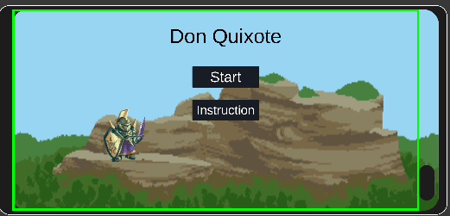

1. **Menu and Screen Descriptions**

*(Include additional screen shots and accompanying descriptions for any menus and additional screen)*

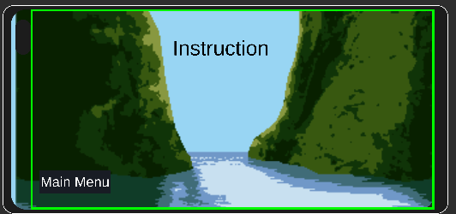

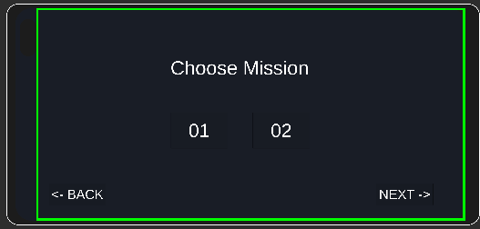

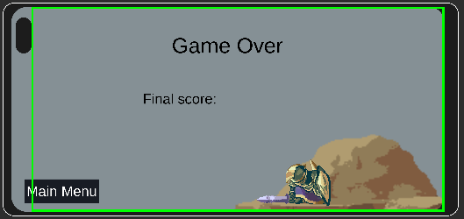

1. **Game World**

*(Describe Your Game Environment)*

**Forest, grassland, hills**

1. **Levels**

*(Describe Each of your game levels)*

**Different levels have different terrain.**

1. **Game Progression**

**Add some assets and make UI ready.**

1. **Characters**

*(Describe Your game avatar if applicable)*

**Legendary knight Don Quixote.**

1. **Non-player Characters**

(Describe Any Computer controlled Allies and how they work)

**No.**

1. **Enemies**

*(Describe computer-generated enemies and boss monsters)*

**Enemy is ordinary knight; boss is a “windmill”.**

1. **Weapons**

*(Describe any weapons available to the user)*

**Sword and shield.**

1. **Items**

*(Describe any in-game items that can help or hinder the user)*

**Food and pharmacy.**

1. **Abilities**

**Just attack and jump.**

1. **Vehicles**

**No, may be have horse.**

1. **Script**

**Knight Adventure Story**

1. **Scoring**

**Attack enemy and take gold.**

1. **Puzzles/Mini-games**

**No.**

1. **Bonuses**

**No.**

1. **Cheat Codes**

**No.**

1. **Sound Index**

*(Include an index of all your sound clips)*

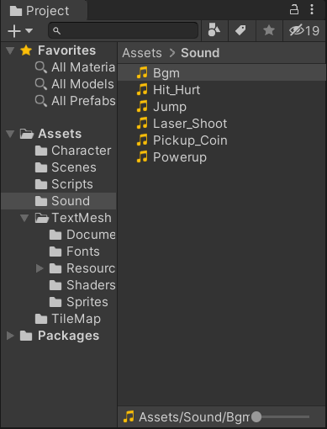

1. **Story Index**

*(Outline your game story here)*

**The knight Don Quixote heard that the princess was trapped in the windmill, so he went to rescue alone. But this “windmill” may be a bit different from what he thought.**

1. **Art / Multimedia Index**

*(Include an index of all your graphic and video assets here)*

**Background and tile map.**

1. **Design Notes**

*(Include additional design notes here)*

1. **Future Features**

*(Include any future features that are planned to be implemented)*

**Add knight control and improve the game screen**